TERRANEXT GLOBAL VENTURES
AI Intelligence Platform
Administrator Guide
Document 2 of 8 · Version 1.0
August 2, 2026
CONFIDENTIAL — Prepared exclusively for TerraNext Global Ventures

Document Control
Document Title | AI Intelligence Platform — Administrator Guide
System | TerraNext Business OS
Classification | Confidential — Client Delivery
Prepared For | TerraNext Global Ventures
Prepared By | Engineering Documentation Team
Status | Final
Related Documents | User Guide; Operations Manual; Installation & Deployment Guide

Version History
Version | Date | Author | Description of Changes
1.0 | 2026-08-02 | Engineering Documentation Team | Initial release — converted from the Markdown source of truth for client handover.

Table of Contents
Right-click this table and choose "Update Field" → "Update entire table" to populate page numbers after opening this document in Word.

ℹ NOTE
The figures in this guide are annotated screen-layout diagrams that reflect the actual structure of each screen — not photographic screenshots.

1. Administrator Responsibilities
As a System Administrator or Founder, you are responsible for:
- Turning on real AI transcription and summarization (§5) — until configured, the platform completes sessions with placeholder text instead of real content.
- Understanding who can see and do what (§2).
- Managing the operational settings on the Settings screen (§4).
- Removing sessions that should no longer appear in the active list (§3).
- Retrying any failed processing job, for any trainer (§6).
- Monitoring the Processing Queue and Analytics screens for overall platform health (§7).

2. Roles & Access
Role | View sessions/transcripts/analytics | Create sessions & record | Remove sessions | Change Settings
Founder | ✅ | ✅ | ✅ | ✅
System Administrator | ✅ | ✅ | ✅ | ✅
Operations Manager | ✅ | — | — | —
Programme Coordinator | ✅ | — | — | —
Trainer | ✅ | ✅ (own sessions only) | — | —
Transformation Consultant, Finance Officer, Career & Placement Officer | — | — | — | —
Notes on how access works in practice:
- A trainer can only record against sessions they themselves created — there's no "record on behalf of another trainer" capability.
- A trainer can retry their own failed processing jobs; System Administrators and Founders can retry anyone's.
- Anyone with view access can see every session across the organization, not only their own branch or their own sessions — this is a shared, organization-wide record by design.
- Removing a session is limited to System Administrators and Founders; trainers cannot remove their own sessions.

3. Managing Sessions
From Sessions, System Administrators and Founders can remove any session using the delete action in its row. This:
- Hides the session from the active Sessions list.
- Keeps the recording, transcript, and summary — nothing is permanently deleted.
- Does not change the session's processing status.
There is no bulk-remove and no "restore" button in the interface — if a session needs to be restored after removal, contact your technical support team.
Every meaningful change — creating a session, finishing a recording, removing a session, changing Settings, or retrying a job — is recorded in the organization's audit log with who did it and when.

4. Settings
Available at AI Intelligence Platform → Settings, visible only to System Administrators and Founders.
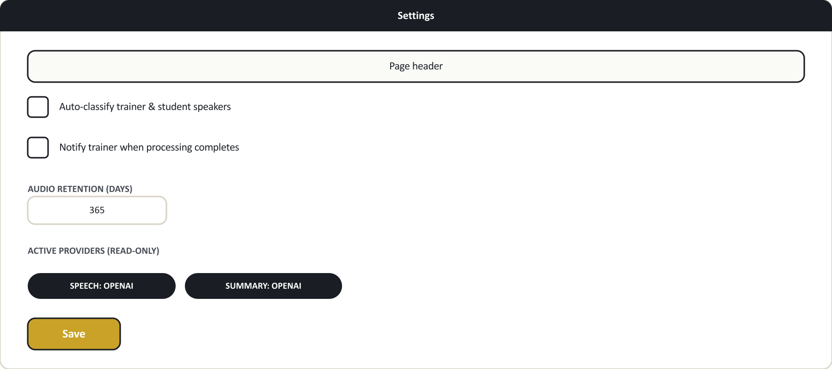
Figure 1. Settings layout (illustrative diagram, not a photographic screenshot).
Setting | What it controls
Auto-classify trainer & student speakers | When on, the platform attempts to label each part of the transcript as Trainer or Student speech. When off, transcript segments are left unlabelled until reviewed manually.
Notify trainer when processing completes | Governs whether trainers receive a completion notification. Confirm with your technical team whether notification delivery is active for your organization before relying on it.
Audio retention (days) | Records your organization's intended retention period for session audio (7–3650 days). Confirm with your technical team whether automatic deletion is active for your organization — this field records policy intent, and you should not assume audio is automatically purged without checking.
Two fields are shown for information only and can't be edited here: Active speech provider and Active summary provider — these show which AI provider actually processed the most recently completed session. If you've just changed provider configuration, these badges update after the next session finishes, not immediately.

5. AI Provider Setup
This is the most important setup task for a new deployment: without configuration, sessions still complete end to end, but with placeholder transcript and summary text instead of real content.

5.1 Default state
Out of the box, the platform runs in a safe demonstration mode. Every session records, uploads, and "processes" successfully, but the transcript and summary will contain a message explaining that a real AI provider hasn't been set up yet. This lets you test and demonstrate the full workflow — recording, uploading, the processing queue, the Completed state — before committing to a provider.

5.2 Enabling real transcription
Turning on real AI processing is a one-time technical configuration step, done by your technical/engineering team on the hosting platform (not from any screen inside the CRM) — for security, the AI service credentials are never entered into or stored in the CRM interface itself. Your technical team will need to know:
- Which AI provider to use: OpenAI or Google Gemini (both are supported; each requires its own account and API key from that provider).
- The provider's API key, provisioned from your OpenAI or Google account.
Once configured, the Active speech/summary provider badges on the Settings screen (§4) will confirm which provider is running after the next session completes.

5.3 Choosing between OpenAI and Gemini
Both providers produce a full transcript with speaker labels and an AI-generated summary — the end result your trainers and coordinators see is the same shape either way. They differ mainly in cost and processing characteristics; ask your technical team for a current cost/performance comparison before deciding, since pricing and capability can change over time. You are not locked into one choice — the platform supports switching between them (or even using one for transcription and the other for summarization).

6. Managing the Processing Queue
As an administrator, you can retry any failed job — not just those you created yourself. Retrying:
- Only applies to jobs that have actually Failed.
- Picks up processing from wherever it stopped — segments already successfully transcribed are not redone.
- Is logged in the audit trail.
There is no bulk "retry all" action today — each failed job is retried individually. There's also no automatic retry — a failed job stays failed until someone clicks Retry.

7. Where to Look When Something Is Wrong
Symptom | Where to check | What you'll find
A session is stuck on Processing for a long time | Processing Queue, that session's row | The exact stage it's at; longer recordings naturally take longer since each segment is processed in turn
A job shows Failed | Same row | The specific error message explaining what went wrong
Provider badge on Settings still shows the demonstration mode after configuring a real provider | Confirm with your technical team that the API key was entered correctly | A misconfigured key falls back to demonstration mode without a separate error message anywhere in the CRM
You need a record of who removed/retried/changed something | Ask your System Administrator to check the audit log | Every meaningful change is recorded with who did it and when

8. Frequently Asked Questions
Do I need to buy separate hardware for recording? No. Any microphone the trainer's computer already recognizes works — USB interfaces, wireless lapel mics, boundary conference mics, or a laptop's built-in mic.
How much does AI processing cost per session? This depends on which provider (OpenAI or Google Gemini) you configure and current provider pricing. Ask your technical team for a current estimate based on your expected recording volume.
Can I limit which trainers can record sessions? Recording access follows the role assignments in §2 — any Trainer, System Administrator, or Founder can create and record sessions. There's no per-trainer allow-list beyond role assignment.
Can I restrict who sees a given session? Not today — anyone with view access to the AI Intelligence Platform can see every session across the organization.
What happens to a session's audio if I lower the retention setting? Confirm with your technical team what retention enforcement is currently active for your deployment before changing this value, so you understand the practical effect.
Can I export a transcript or summary to a file? Not from the current screens — check with your technical team about export options for your organization.
Who do I contact for AI provider billing or API key issues? Your technical/engineering team manages the AI provider account and API key configuration — they are your first point of contact for provider-side billing or key issues.

